**Enhance Your PDFs with Multiple Hyperlinks in a Single Grid Cell Using Syncfusion .NET PDF Library**

The Syncfusion Essential® PDF is a [**.NET PDF library**](https://www.syncfusion.com/document-processing/pdf-framework/net) used to create, read, and edit PDF documents. This guide demonstrates how to add multiple URI annotations within a single PDF grid cell using C# to create interactive links.

**Steps to Add Multiple URI Annotations in a PDF Grid Cell**

1. **Set Up Your Project**: Create a new console application project in your development environment.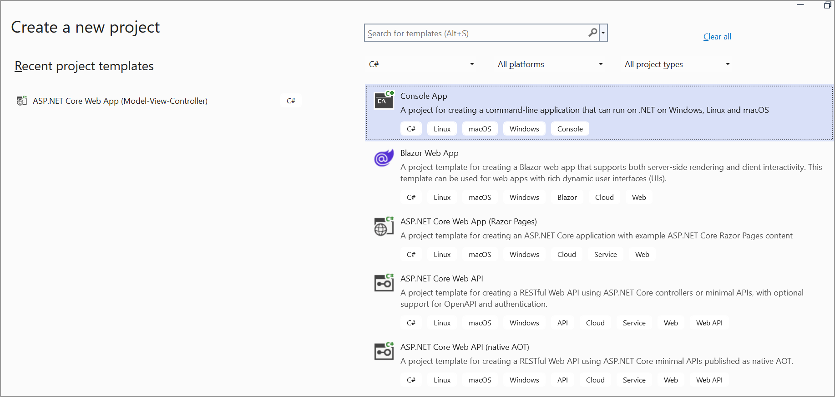

2. **Install Syncfusion Package**: Add the [Syncfusion.Pdf.Net.Core](https://www.nuget.org/packages/Syncfusion.Pdf.Net.Core/) package from NuGet to your project.

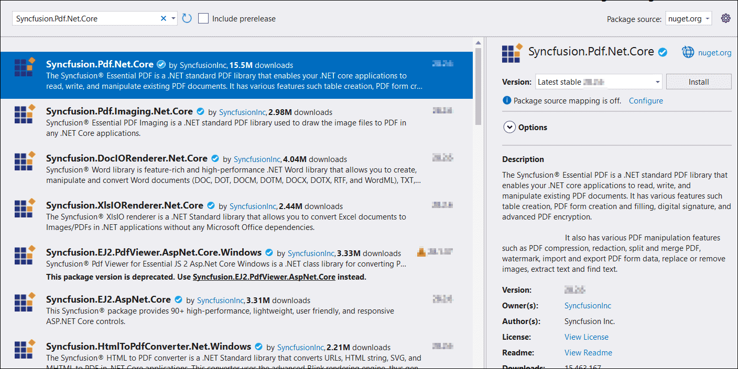

3. **Include Required Namespaces**: Add these namespaces to your **Program.cs**.

**C#**

|  |
| --- |
| using **Syncfusion**.Pdf.Graphics;  using **Syncfusion**.Pdf.Grid;  using **Syncfusion**.Pdf.Interactive;  using **Syncfusion**.Pdf;  using **Syncfusion**.Drawing; |

4. **Implementation**: Use the following code to add multiple URI annotations within a single PDF grid cell:

**C#**

|  |
| --- |
| // Create a new instance of PdfDocument  PdfDocument document = new PdfDocument();  document.PageSettings.Orientation = PdfPageOrientation.Portrait;  document.PageSettings.Margins.All = 5;  PdfPage currentPage = null;  document.Pages.PageAdded += (sender, args) => { currentPage = args.Page; };  // Add a new page to the document  PdfPage page = document.Pages.Add();  PdfGraphics graphics = page.Graphics;  // Create a new PdfGrid  PdfGrid pdfGrid = new PdfGrid();  pdfGrid.Columns.Add(3);  PdfGridRow row1 = pdfGrid.Rows.Add();  row1.Cells[0].Value = "Employee Details";  row1.Cells[0].ColumnSpan = 3;  PdfGridRow row2 = pdfGrid.Rows.Add();  row2.Cells[0].Value = "Employee ID";  row2.Cells[1].Value = "Employee Name";  row2.Cells[2].Value = "Website";  PdfGridRow row3 = pdfGrid.Rows.Add();  row3.Cells[0].Value = "E01";  row3.Cells[1].Value = "Simons Bistro";  row3.Height = 50;  pdfGrid.BeginCellLayout += PdfGrid_BeginCellLayout;  PdfStringFormat format = new PdfStringFormat();  format.Alignment = PdfTextAlignment.Center;  pdfGrid.Rows[0].Cells[0].StringFormat = format;  // Draw the PdfGrid  pdfGrid.Draw(page, new PointF(10, 10));  // Saving and closing the document  using (MemoryStream stream = new MemoryStream())  {  document.Save(stream);  File.WriteAllBytes("Output.pdf", stream.ToArray());  }  document.Close(true);  void AddHyperlink(PdfPage page, RectangleF bounds, string url)  {  PdfUriAnnotation uriAnnotation = new PdfUriAnnotation(bounds, url);  uriAnnotation.Border.Width = 0;  uriAnnotation.Text = url;  page.Annotations.Add(uriAnnotation);  }  void PdfGrid_BeginCellLayout(object sender, PdfGridBeginCellLayoutEventArgs args)  {  if (args.RowIndex == 2 && args.CellIndex == 2)  {  PdfFont font = new PdfStandardFont(PdfFontFamily.Helvetica, 10, PdfFontStyle.Regular | PdfFontStyle.Underline);  string text = "Google";  SizeF textSize = font.MeasureString(text);  RectangleF linkBounds = new RectangleF(args.Bounds.X, args.Bounds.Y, textSize.Width, textSize.Height);  args.Graphics.DrawString(text, font, PdfBrushes.Blue, linkBounds);  AddHyperlink(currentPage, linkBounds, "https://www.google.com");  float positionY = args.Bounds.Y + textSize.Height + 2;  text = "Yahoo";  textSize = font.MeasureString(text);  linkBounds = new RectangleF(args.Bounds.X, positionY, textSize.Width, textSize.Height);  args.Graphics.DrawString(text, font, PdfBrushes.Blue, linkBounds);  AddHyperlink(currentPage, linkBounds, "https://www.yahoo.com");  }  } |

A complete working sample can be downloaded from [**Multiple_URI_annotation_in_a_single_PDF_grid_cell.zip**](https://www.syncfusion.com/downloads/support/directtrac/general/ze/URI_annotation_in_grid_cell1397661008.zip)

By executing the program, the output PDF document will be generated as shown below.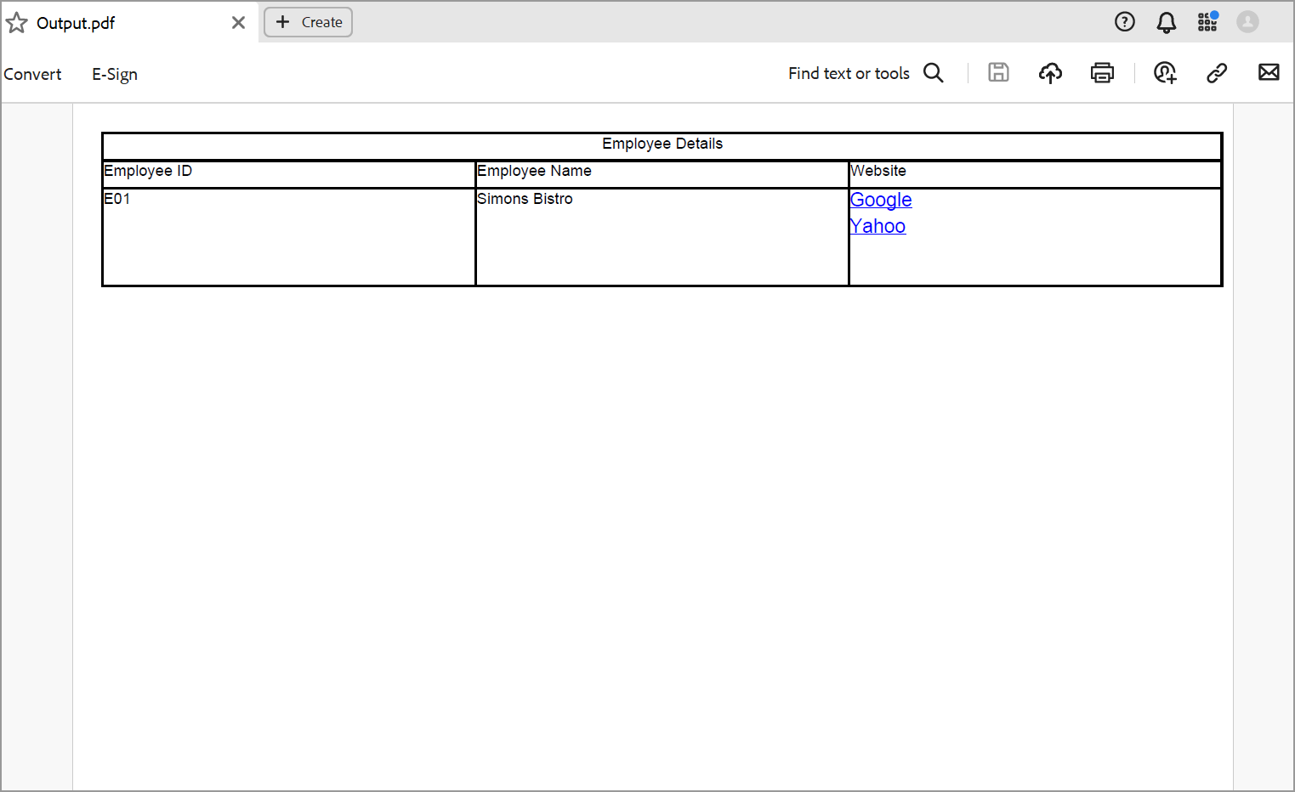

Take a moment to explore the documentation on [working with tables](https://help.syncfusion.com/file-formats/pdf/working-with-tables), where you'll find additional options such as grid pagination and various levels of grid customization.

**Conclusion**  
I hope you enjoyed learning about how to add multiple URI annotations in a PDF grid cell.

You can refer to our [**ASP.NET Core PDF**](https://www.syncfusion.com/document-processing/pdf-framework/net-core) feature tour page to know about its other groundbreaking feature representations and [**documentation**](https://help.syncfusion.com/aspnet-core/pdf/getting-started), and how to quickly get started for configuration specifications. You can also explore our [**ASP.NET Core PDF example**](https://www.syncfusion.com/demos/fileformats/pdf-library) to understand how to create and manipulate data in the .NET PDF.

For current customers, you can check out our Document processing libraries from the [**License and Downloads**](https://www.syncfusion.com/account/downloads) page. If you are new to Syncfusion®, you can try our 30-day [**free trial**](https://www.syncfusion.com/downloads/aspnetcore-js2) to check out our ASP.NET Core PDF and other .NET Core controls.